Work report 25 july 2021

Today I firstly fixed the error I was getting during detection of objects in yolo v4.

Then I have taken tested the model on some images the results were very good/

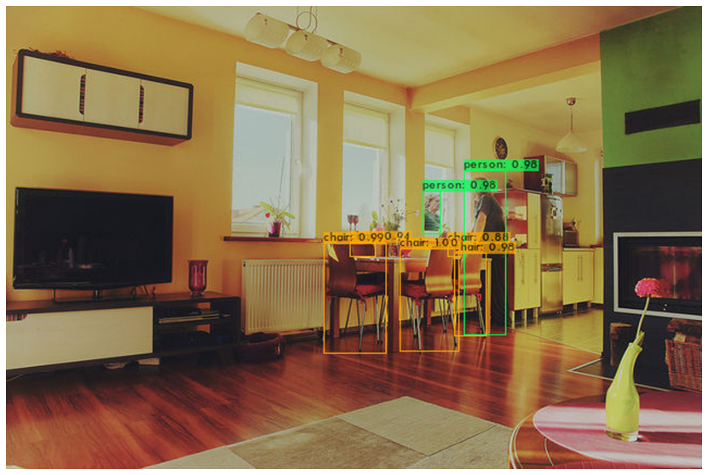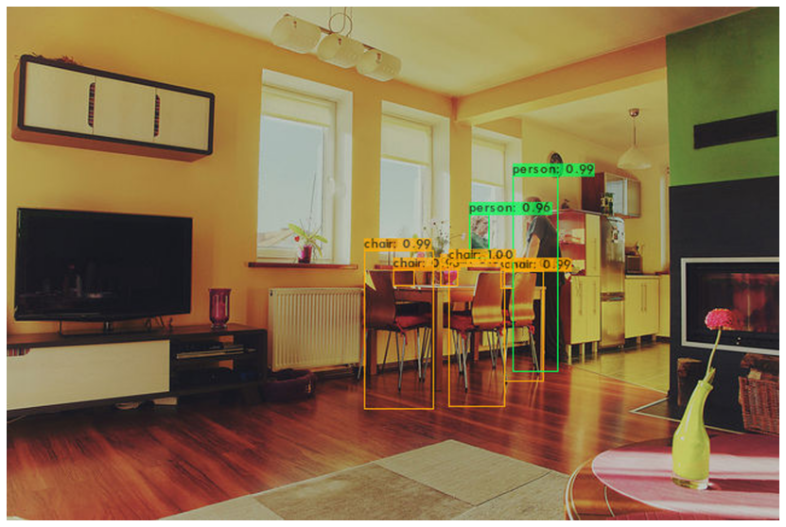

First image was at 3900 epoch and the second one is of 5900 epochs.

Then I have checked it on some images more and the results were very good.

Then after I have started checking on videos.

The results are as follows:

|  |  |  |
| --- | --- | --- |
| Video Quality | Fps | Output link |
| 120(3900 epoch) | 5.6 | <https://drive.google.com/file/d/1eRrB3q1Knz3XEZkddOHSDgjduifN-NKe/view?usp=sharing> |
| 120(5900 epoch) | 5.3 |  |
| Not Good quality images(Images downloaded from internet and then made as a video)(5900) | 46.8 |  |
| Aeroplane(720p) | 36.6 | <https://drive.google.com/file/d/11m2Je-q6YqM2x0b9YwcsNNwfOIgYX4xy/view?usp=sharing> |
| Tesla charging(120 fps) | 4.9 | <https://drive.google.com/file/d/1mJFXmn3qQPO-1dqAxOZ7yqv_KyFadcGi/view?usp=sharing> |
|  |  |  |

Then after I have taken one video

<https://drive.google.com/file/d/11ktiBr0KWVZ7-Sy5KfXxGUqnI1zhh8pQ/view?usp=sharing>

and I have taken different qualities of this video:

|  |  |
| --- | --- |
| Video Qualitiy | Average Fps we get |
| 144p | 53.2 |
| 360p | 52.0 |
| 480p | 51.1 |
| 720p | 39.4 |
| 1080p | 20.5 |
| 1440p | 12 |
| 2160p | 4.3 |

I have not uploaded every detection result on drive but to see how detection looks like in this video is :

<https://drive.google.com/file/d/1dFS3JaCgJ7Mb79bJEBvjyiE01jqlH0cQ/view?usp=sharing>